“MINDS into MATTER –
the "Book of Business" sustainable training tool in the tourist industry”

Project Nr: 2016-1-IS01-KA202-017090
Erasmus+ KA2 Strategic partnership project

The multiplier event
Nelijärve, ESTONIA, August 28, 2018

Meeting for project members and foreign guests in Pääsuke villa

Coordinator of the project Hansina B. Einarsdóttir (Step by step, Iceland) and leader of host organisation Ruta Pels (Eesti People to People, Estonia) welcomed guests.

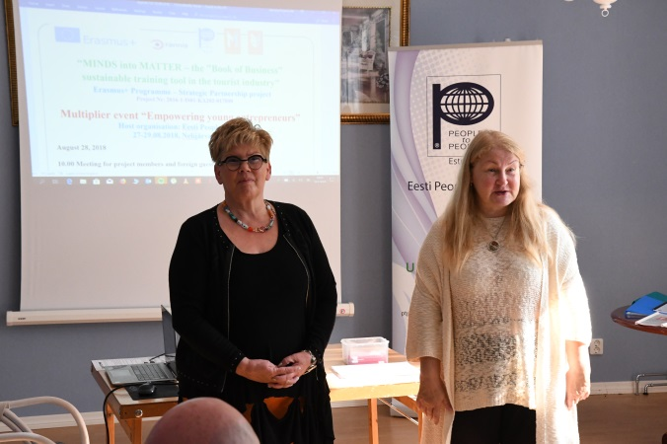

* Presentation of participants:
Each partner introduces the guests and turbos that has come from each country for this event. Czech Republic and Poland came with all their turbos, for Lithuania and Spain it has not been possible. Lithuanian mentors came with students and Spanish team had two mentors. Iceland had one of the turbos.

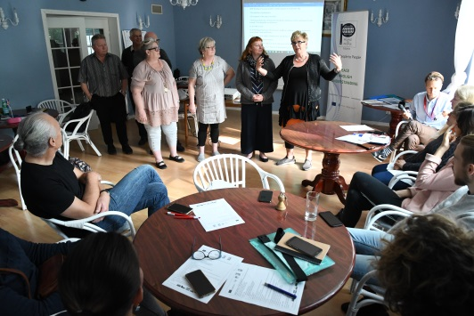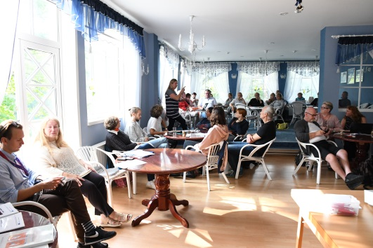

* Presentation of the project brochure:
Daine Rinkeviciute (Lithuania) makes the presentation of the brochure that has been designed by her. She has gone through all the design, collection images, logos and text from all the partners to get a final good quality brochure about the project. Every partner will be able to have around 80 copies to distribute in her country.

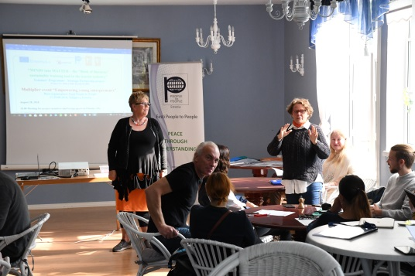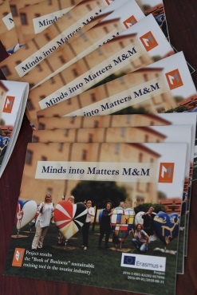

* Sharing good practices from project members:
Turbos assisting in the meeting make an introduction about their companies and what they do, as well as how working with their mentors has been during these two years.
After that in the groups of four-five project members and guests we shared the good practices and exchange experiences. At the end of the meeting every team made presentations about what they have talked and the results. Some of the turbos explained the difficulties they have found being small companies and finding time to work with their mentors. Some others explained technical difficulties of their specific business and how they have solved them.
In the case of Tenerife, Pepa Ruiz Perez, mentor of Hoviam La Pinta Hotel, explained the big differences of making BoB (Book of Business) for a big company who has been working for many years. There she could notice that BoB has been a tool for unification of the work and helped the different departments and teams to work in the same line and direction to be more efficient and improve the working time invested in every task.
Wieslawa Gąsiorowska from Poland pointed out what the BoBs means for turbos (tourism rural business owners) a very professional way of presenting the companies and the useful tool for the future of the turbos professional career.

Estonian National Radio made interviews with five participants of Multiplier event.

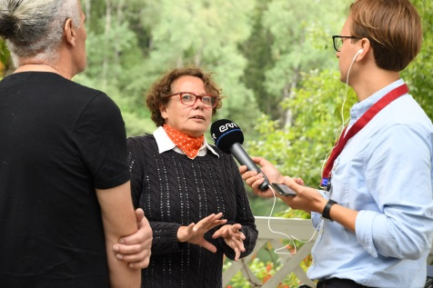

Multiplier event “Empowering young entrepreneurs”
with local and foreign guests in the Main Building

Coordinator of the project Hansina B. Einarsdóttir (Step by step, Iceland) made presentation of the project. Hansina B. Einarsdóttir (Iceland), Eva Svobodova (Czech Republic), Ruta Pels (Estonia), Daine Rinkeviciute (Lithuania), Wieslawa Gasiorowska (Poland) and Mariví Gracia Osanz (Spain) made presentations about work on the Books of Business.
During the event, all the project partners had the opportunity to present the work done during two years, answering the questions of the participants who were very interested in it.

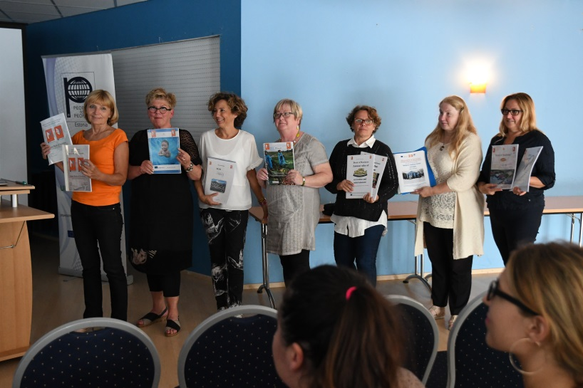

The owner of Nelijärve Puhkekeskus, turbo Reet Purre made a presentation of her business and the time she has been running it.

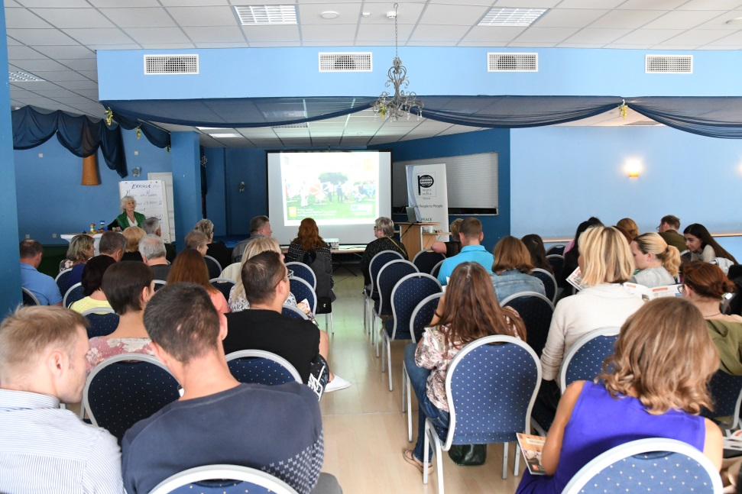

The event finished with a networking and coffee break.

